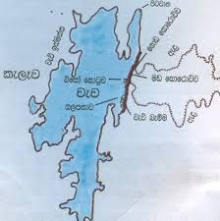**Parts of an ancient tank**

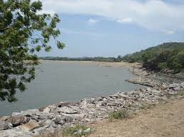**Salapanawa /Ralapanaawa**

* An earthen construction (layer of rough stone boulder) to avoid embankment erosion and to prevent damage to the tank bund due to wave action. Protect the inside of the dam
* Avoid erosion of dam with often water waves
* Consists of Rocks or grass

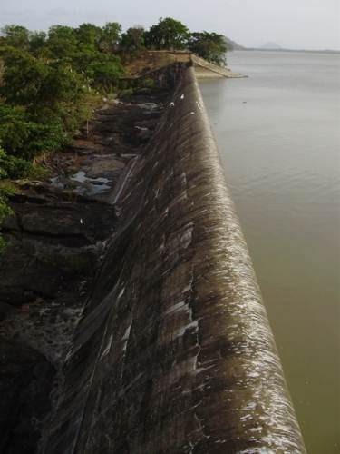**Spill ways/ Pitawana**

A tank must have provision to manage excess water as that would cause pressure on the tank bund and destroy it. So that the excess water could continuously flow out of the tank without causing any danger to the tank bund. Release excess water during heavy rain fall when tank is full

**Thisbambe**

* (tis = thirty. Bambe = a linear measurement –6 ft) A strip of reserved land around the hamlet for protection
* Buffer zone of hamlet, resting place of buffalo, protection from malaria and wild animals, sanitary activities, nutrient source to paddy field

**Kattakaduwa/Interceptor**

* Downstream wind barrier
* Three land phases (water hole, marshy land and dry upland)
* Reduce tank seepage
* Prevent entering Na, Mg, Fe into the paddy land
* Safeguard the tank bund

**Kiul Ela**

* common drain of the irrigated area
* disposal of saline water from kattakaduwa
* bio-diversity
* habitats for predators

**Godawala**

* “Upland hole” in English.
* Upstream sediment trap
* drinking water for cattle and wild animals

**Gasgommana/ Perahana**

* Literally means a sieve or filter in English. A grass strip on the periphery of the water body a silt trap
* (gas = trees; gommana = plenty). An area planted with large tress of the same species that act as a wind breaker to minimize evaporation from the tank surface. It also provides some ecosystem services: dry season fruits, timber, nesting for birds
* Wind barrier – reduces evaporation
* Reduces temperature
* Habitat of some species
* Fish breeding points
* Territory between man and wild animals
* Reduce sedimentation

**Iswetiya**

* upstream conservation bund built on the periphery of the water body
* Soil erosion control, prevent sedimentation, acts as a temporary water pond

**Bisokotuwa (Cistern Sluice)**

* regulate the outward flow of water from the reservoir
* The sri lankan invention of a water releasing mechanism for reservoirs. In 1909 Parker declared that the Sinhalese were the first inventors of the valve pit more than 2100 years ago ( Bailey 1855 )
* It control and timely release of water from large reservoirs while guarding against sudden surges that may pose a danger to the sluice barrel.

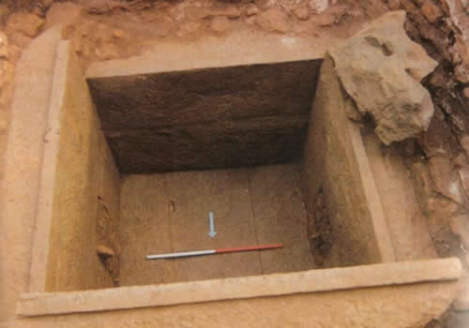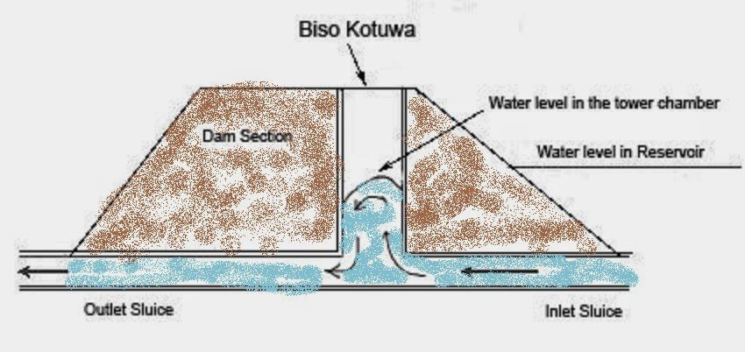

**Sorowwa**

* Release water to stream before enter to the irrigation system.
* Made by black stone.
* There are two types, Mada Sorowwa and Goda Sorowwa.

1. Goda Sorowwa (Keta Sorowwa)- Releases water from the top surface of the reservoir. 6'', 9'', 12'' are available.
2. Mada Sorowwa- Releases water when water level is bottom of the reservoir and remove the clay and sediments.

